Riphah International University
Gulberg Green Campus Islamabad
Faculty of Computing (WISH)



Name: Anisha Rehmat.
Sap ID: 78019.
Submitted To: Mam Nayab Khalid
Submitted by: Anisha Rehmat.

Supervision and Coordination

Miss Hira Jafar
Lecturer
Faculty of Computing

Lab Designers

Miss Nayab Khalid
Teaching Fellow
Faculty of Computing

Lab Task 10

Learning Objectives

After completing this lab, students will be able to:

· Understand the basics of GUI and Java Swing.

· Design forms using NetBeans GUI Builder (Drag and Drop).

· Use Swing components such as JFrame, JLabel, JTextField and JButton.

· Implement button events and handle user interactions.

· Create multiple screens and navigate between them using Java code.

Lab Tasks

- Create a Registration Form using NetBeans GUI Builder. Students must use JFrame, JLabel, JTextField, JPasswordField, JButton ,Colours and event handling.
Step by Step procedure:-
- Creating a Java class:-
Created a new Java file named RegistrationForm.java in the project folder.
- Importing libraries:-
Imported Swing and AWT libraries.
- 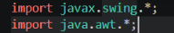
- Declaring GUI components:-
Declared labels, text fields, password field and buttons required for the registration form.
- Creating the constructor
Created the constructor and configured the JFrame window.
- Initializing components
Created Full Name, Username and Password fields, along with Register and Clear buttons.
- Applying colours
Used setBackground() and setForeground() to customize the appearance of the form.
- Arranging components
Used JPanel and GridBagLayout to organize all components inside the registration window.
- Implementing event handling
Added ActionListeners to the Register and Clear buttons.
- Implementing registration validation
Used an if-else statement to check whether all fields were filled.
- If all fields were completed, a registration success message appeared. Otherwise, a warning message was displayed.
- Executing the application
- Ran RegistrationForm.java using the Run option in VS Code and tested its functionality.

Code:-

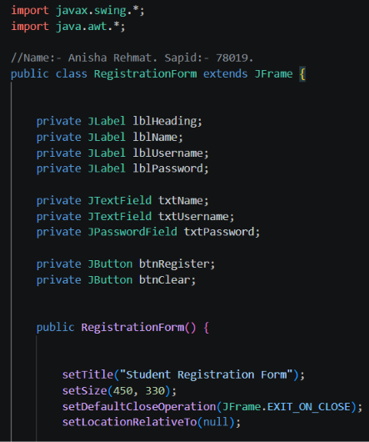
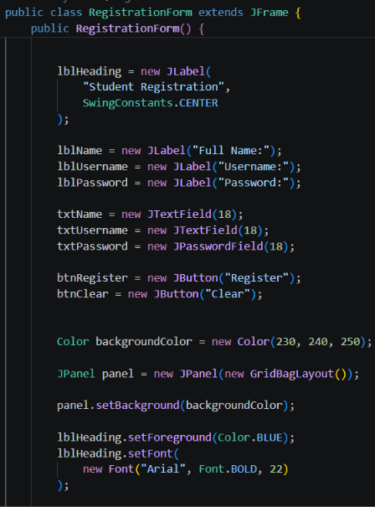
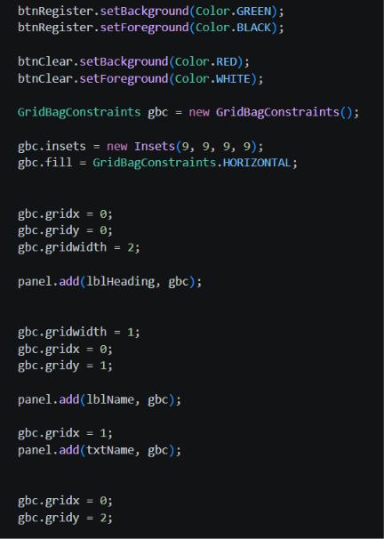
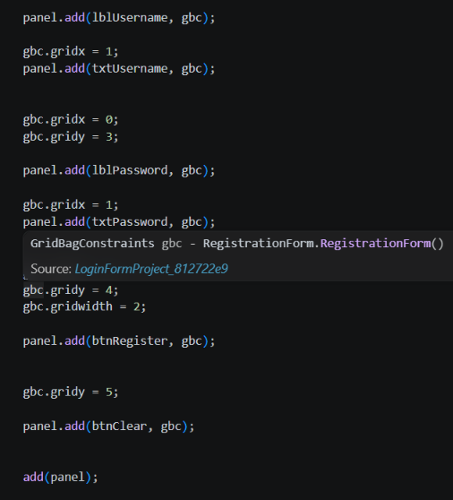
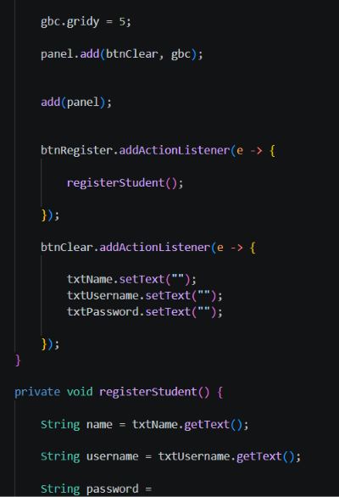
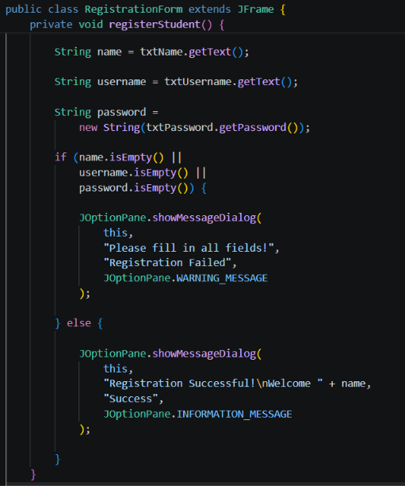

Output:-



